Loading program using flash magic

Flash Magic is Windows software which allows easy access to all the In System Programming (ISP) features provided by the devices.
These features include:
• Erasing the Flash memory (individual blocks or the whole device)
• Programming the Flash memory
• Reading Flash memory
• Reading the signature bytes
• Reading and writing the security bits
• Direct load of a new baud rate (high speed communications)
• Sending commands to place device in Boot loader mode
Flash Magic provides a clear and simple user interface to these feature
INSTALL FLASH MAGIC
Go to Software and Drivers folder and open the folder flash magic version 5.29 and then click on the flash magic application file.
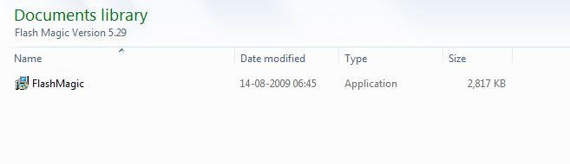
After installation, ‘Flash Magic’ icon will appear on the desktop.
Step 1: Go to ‘Flash Magic’ Icon, it will open the main window as show below.

In main window you can see five types of sections.
• Communications
• Erase
• Hex File
• Options
• Start

Step 2: Go to “Option” in the toolbar, and select first menu ‘Advance options.’

It will show you extracted window with many options.

Uncheck the box which is highlighted to don’t allow Flash Magic to control PSEN & RST using DTR & RTS.

Step 3: Now go for Communication selection, select ‘COM 1’ from ‘COM PORT’
Option if you are using serial port. If you are using USB to serial converter from NEX Robotics then find out COM port number with the help of documentation provided with the USB to serial converter.

Select ‘Baud Rate’ 9600 from Baud Rate option.

Select proper Device ‘89V51RD2’ from Device option.

Step 4: Go to ‘Erase’ section for erasing the all ‘Flash’ or Blocks used by
‘HEX File’
Check on the check box to Erase all Flash.

Step 5: Go to ‘HEX File’ section click ‘Browse’ to select proper Hex file which is to
be loaded into Fire Bird V P89V51RD2 Robot.

Step 6: Go to ‘Option’ section to select ‘Verify after programming’ option. This will verify hex file after loading.

Step 7: After doing all the required settings, connect serial cable between robot and PC. Turn on the Fire Bird V P89V51RD2 robot and click on the ‘Start’, it will ask to ‘RESET TO DEVICE IN TO ISP MODE’, now press RESET Switch on the Fire Bird V, Flash magic will load hex file on the robot and verify it for correctness.
If you are using NEX Robotic’s USB to serial converter then please refer to Chapter 6. PC Based Control Using Serial Communication for how to use it and identify COM port number.

